Project Report

On

Bank Management System

By-

Shriyash Anand Kerimane

ABSTRACT

The goal of this project is to create online banking system for bank users. With the right login, the system, which is an online application, may be accessed both inside and outside the company.

A project that monitors a client's bank account is the bank management system project. This project covers the key features of bank management software and illustrates how a banking account system works. In order to suit the needs of an end banking user, it develops a project for resolving a customer's financial applications in a banking environment by offering a variety of ways to carry out banking tasks.

Banking System is application which will allow employees and customers to perform day to day financial task and not requiring to visit bank.

The application is embedded with monitoring feature like Prometheus and

Grafana which will allow bank personnel to monitor request traffic on the website for every single request.

Contents

**1 Introduction**

* 1. Overview
  2. Objectives
  3. Problem statement

1. **System design**
   1. Microservice architecture
   2. Use case diagram
   3. ER diagram
2. **Implementation details**
   1. Technologies used
   2. Functional requirements
   3. Microservices and its end points
3. **Conclusion**

4.1 Conclusion

Introduction

* 1. **Overview:**

Banking System is application which will allow employees and customers to perform day to day financial task and not requiring to visit bank

* 1. **Objectives:**
* Create an application that can perform basic functionality of banking system for customers
* Create an application which will allow an employee to monitor and update status of customers
* An application with login for validation of user
* Send email to customers after registration
* Deployment of application on to AWS server(EC2).
* Monitor request traffic on Grafana.
  1. **Problem statement:**

The Banking System application allows Customers and Bank employees to carry out daily banking tasks and transactions. Implement the Banking System using microservices architecture.

System design

**2.1 Microservice Architecture**

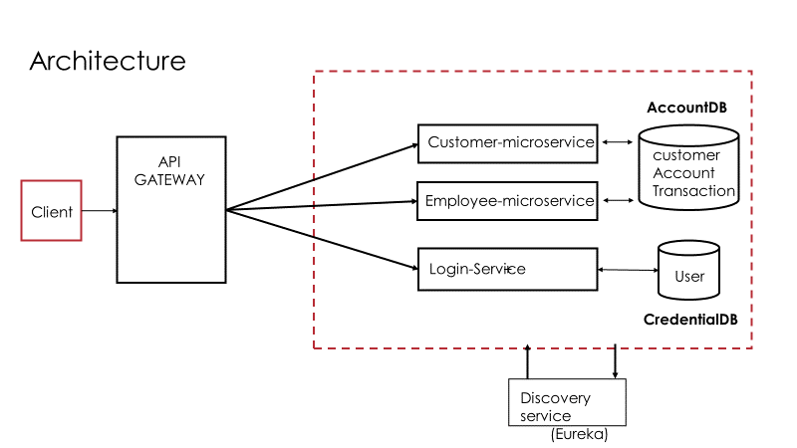

**2.2 Use case diagram**

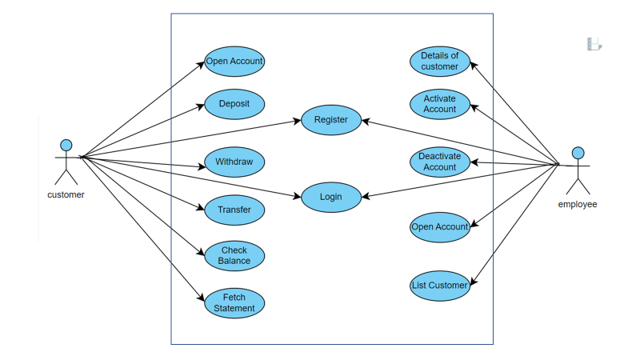

**2.3 ER diagram**

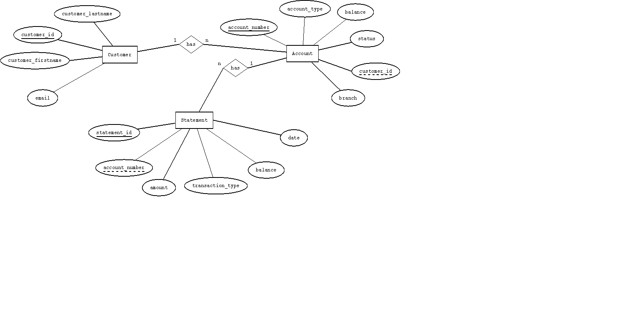

Implementation Details

**3.1 Technologies used**

* Java JDK 11
* Spring boot, spring data JPA
* Spring cloud
* Thymeleaf
* MariaDB

**3.2 Functional requirements**

**-**By customer

* Register to access bank functionality
* Login functionality
* Open accounts
* Transaction - deposit, withdraw, transfer
* Check balance
* Fetch transaction statement
* Get email notification on registration

-By employee

* Get customer details
* Open accounts for customers
* Activate or Deactivate accounts
* List customers

**3.3 Microservices and its end points**

This project contains 3 micro-services:

1. Login-microservice
2. Customer-microservice
3. Employee-microservice
4. Login-microservice:

This microservice validates the credentials of user and based on credentials and if provided input match with credentials in database, requests redirect to either customer home page or employee home page.

* Register new user: “/register”
* Login: “/”

1. Customer-microservice:

This microservice works on the functionality related to customer end. It provides with the feature of basic bank functionality like deposit, check balance, get statement and so on.

* Create new account: “customer/createaccount”
* Deposit: “customer/deposit”
* Withdraw: “customer/withdraw”
* Transfer amount: “customer/transfer”
* Check balance: “customer/checkbalance”
* Fetch statement: “customer/statement”

1. Employee-microservice:

This microservice works on the functionality related to employee end. It provides with the feature of bank functionality like list customers, activate or deactivate accounts and so on.

* Get customer Details: “/employee/customerdetails”
* Change account status: “/employee/accountstatus”
* Create accounts: “ /employee/createaccount”
* List all customers: “/employee/listall”
* Save customer in DB: “/employee/savecustomer”

**Conclusion**

* 1. **Conclusion**

This project is developed and incorporated with all the functionalities mentioned above (3.2) with respect to customer and employee.

With the usage of this system, it gives the management and the customer all the information they require; the user only needs to sit in front of the system to keep track of all operations without moving the file physically. Management can respond to client requests in a timely manner.